Department of Information Technology Law and Legal Professions
Faculty of Law and Administration
Maria Curie-Sklodowska University of Lublin
has the honour to invite you to:
THE FIRST LUBLIN SYMPOSIUM ON INFORMATION TECHNOLOGY LAW
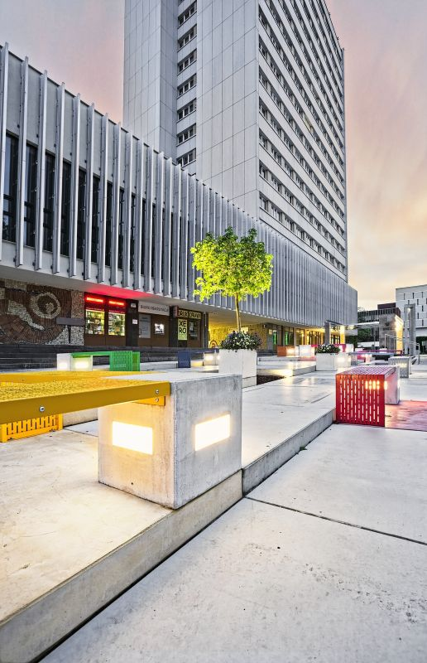
International Conference “Legal professions in the environment of modern digital transformations. Challenges and dilemmas” – Lublin, Poland, March 6-8, 2024

The agenda includes, in particular:  1. issues concentrating around the legal and organisational challenges facing the legal professions of public interest, the public administration,  2. the issue of cyber security  3. the use of artificial intelligence (AI) in the provision of legal assistance  legal aid,  4. modern algorithmic solutions and their impact on the legal services market  legal services market,  5. digital transformation in the social sphere,  6. the current digital challenges faced by those practitioners of various legal professions (in the context of emerging or possibly emerging threats)  - taking into account the level of normative regulation in the face of ongoing digital change.  Co-organiser:  - European Association of Lawyers (AEA-EAL), Brussels, Belgium  Patrons of the project:  - Regional Chamber of Legal Advisers in Lublin  - Regional Bar Council in Lublin  - NASK - National Research Institute  Media patronage: Palestra  The framework programme and details of the conference are available at: www.spi.lublin.umcs.pl |  | The main objective of the Symposium is to present and exchange the latest scientific findings in the emerging field of IT law. The initiation of the Symposium with the theme of contemporary digital transformations and their impact on the practice of public law is a clear signal (to the national and international legal communities) of the necessity to deepen and re-contextualise previous scientific and practical experiences.  Date: March 06-08, 2024  Place: Faculty of Law and Administration, Maria Curie – Sklodowska University in Lublin, ul. Marii Curie Sklodowskiej 5, 20 – 031 Lublin, Poland  Submission of applications:  - confirmation of participation in the conference - by 20.01.2024  - subject matter of the presentation with abstract (up to 2000 characters) - by 31.01.2024  - article for publication (for those who have declared their intention to do so) – by 25.02.2024  Please send applications using the form attached to this letter to: spi.lublin@mail.umcs.pl  Publication:  The articles will be published in a multi-author monograph, in the journals Lex localis - Journal of Local Self-Government and Studia Iuridica  Lublinensia depending on the classification by the Conference Scientific Committee.  Please send your articles to the following address: spi.lublin@mail.umcs.pl

Registration form:

International Conference “Legal professions in the environment of modern digital transformations. Challenges and dilemmas” – Lublin, Poland, March 6-8, 2024

Forename*
Surname*
Phone number*:
E – mail address*
Participation**:
- passive;
- active (presentation of the paper/poster)

Title of paper/poster issue (if actively participating):
Abstract (up to 2000 characters, please send to: spi.lublin@mail.umcs.pl by 31.01.2024):

Are you interested in an optional tour of Lublin on 08.03.2024 (afternoon)*?
- Yes
- No
Are you interested in an optional excursion to Zamość on 09.03.2024 (Saturday)*?
- Yes
- No
I plan to participate in*:
- the entire event (6-8 March 2024)
- the second day of the conference (7 March 2024)
- the third day of the conference (8 March 2024)
Planning accommodation*:
- from March 6/7, 2024;
- from March 7/8, 2024;
- from March 6/7 and March 7/8, 2024;
- I am planning an additional overnight stay from March 8/9, 2024
- I will not be using overnight stays;
Other suggestions:…………………………………………………………………………………………………………………………
Personal data* I consent to the processing of my personal data by the Faculty of Law and Administration of the Maria Curie-Skłodowska University included in the application form for the purposes of the organisation of the symposium including the inclusion of my name on the list of participants in accordance with the Act of 10 May 2018 on the protection of personal data. (consolidated text: Journal of Laws 2019, item 1781).

The University of Maria Curie-Skłodowska (hereinafter also "UMCS") informs you that:
1. The controller of your personal data is the University of Maria Curie-Skłodowska in Lublin with its seat in Lublin, pl. Marii Curie-Skłodowskiej 5, 20-031 Lublin.
2. The University of Maria Curie-Skłodowska has appointed a Data Protection Officer (hereinafter referred to as "DPO"), who can be contacted via e-mail: iod@mail.umcs.pl.
3. The DPO can be contacted on any matter concerning the processing of personal data.
4 Your personal data will be processed in order to participate in THE FIRST LUBLIN SYMPOSIUM ON INFORMATION TECHNOLOGY LAW. The basis for the processing of your personal data is Article 6(1)(a) of the GDPR - consent to the processing of personal data on the basis of your consent to the processing.
5. The provision of your personal data is necessary for the conclusion of the contract and the performance of the contract.
6. The Administrator shall receive your personal data either directly from you or from contractors.
7. Your personal data may be made available to entities entitled to receive the data on the basis of generally applicable legal regulations.
8. Your personal data, in legally justified cases, may be transferred to third countries (outside the European Economic Area) and to international organisations.
9. Your personal data will be stored for the period necessary for the performance and settlement of the Contract, as well as until the statute of limitations for claims that may arise from the performance of the Contract, and, to the extent indicated in para. 4 above - until you withdraw your consent to the processing
10. You have the right to: obtain information about the processing of your personal data and your rights under the RODO, access to and rectification of the content of your data, and the right to have your personal data erased from the controller's files (unless further processing is necessary to comply with a legal obligation or to establish, assert or defend your claims), and the right to restrict processing, data portability, object to processing - in the
in the cases and under the conditions set out in Article 13 GDPR.

To the extent to which the processing is based on your consent, you have the right to withdraw your consent at any time without affecting the lawfulness of the processing carried out on the basis of your consent prior to its withdrawal.
11.Your personal data will not be subject to automated decision-making or profiling.
12.You have the right to lodge a complaint with the President of the Data Protection Office if you consider that the processing of your personal data violates the provisions of the GDPR.

*Required
**Select as appropriate

