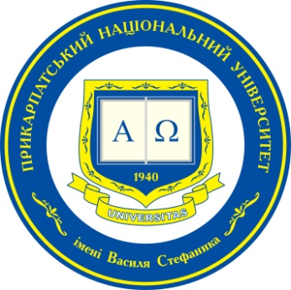

International online conference for young scientists and scholars

Integration and Disintegration Processes in the Modern World

Saturday, December 18th, 2021

Topics of Interest and Call for Scientists and Scholar Submissions

The potential participants are invited to prepare a presentation that covers a wide range of issues related to the integration and disintegration processes, including the following:
- Ukraine in the context of bilateral relations with key international partners.
- Integration processes in the theory of international relations.
- Essence and causes of disintegration processes.
- Disintegration processes in EU countries.
- Brexit and its impact on integration processes in Europe.
- Integration and disintegration processes in the post-Soviet space.
- Phenomenon of separatism: theoretical and practical dimension.
- Essence and manifestations of separatism in the post-Soviet space.
- Separatism as a real or potential threat to the EU, the US, and other influential players.
- Supporting separatism as a mechanism of destabilizing the situation at the local, regional and global levels.

- Other related topics are welcome.

Conference language: English

APPLICATION FORM
For participation
in International conference for young scientists and scholars:
Integration and Disintegration Processes in the Modern World

December 18th, 2021

Participant’s Name and Surname: …….………………………………………

Institutional Affiliation: ..…………………………………………………………

Position in Home Institution: ..…………………………………………………

Presentation Title: ...….……………….………………………………………….
or
Participation in the discussion only…………………………………………

Telephone: .…………………………………………………………………………

E-mail: ……………………………………………………………………………….

Application Deadline: December 8th, 2021
Ihor Hurak
tel. (+38 097) 159 91 97
e-mail: ihorhurak@gmail.com

