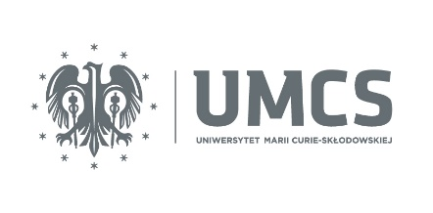

First Name:
Surname:
ADDRESS:
PESEL:

Passport No.:_______________________________________________________________________

Statement

I, the undersigned, express my readiness to undergo vaccination against disease caused by SARS-CoV-2 (COVID-19) infection.

A declaration of consent to the processing of personal data
I consent to the processing of my personal data in the form of: name, surname, PESEL number, telephone number, e-mail address and address of residence by the Maria Curie-Sklodowska University in Lublin and the Independent Public Clinical Hospital No. 1 in Lublin, as well as for sharing this data: Center e-Health, the Ministry of Health, the National Health Fund and entities involved in the organization and implementation of vaccinations, in order to organize and implement the vaccination process against the disease caused by infection with the SARS-CoV-2 (COVID-19) virus.

Date |  | Signature

