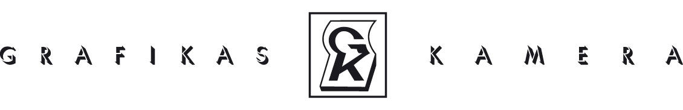
Biedrība “Grafikas kamera”Reģ. Nr. 9000800853411. Novembra krastmala 35, LV1050, Riga, Latvia
INVITATION

We invite you to participate in the exhibition “THE FLEA” organised by the association “Grafikas kamera” and Šiauliai County Povilas Višinskis Public Library, to be held from April 2020 in Šiauliai County Povilas Višinskis Public Library before continuing on to the following exhibition halls in Latvia until 2022: The Art Gallery “Romas dārzs” (the Roman garden), Daugavpils Rothko Art Centre, Liepaja (November, 2020).

For the eighth year running, the association “Grafikas kamera” is inviting artists working with various graphics techniques to share their creative ideas and latest miniature works.
This year’s theme is dedicated to small insects - FLEAS – and is derived from the latvian folk expression “Everyone has their own fleas.” Everybody, including artists, has their personal quirks – positive and negative drives which help the creative process. Whereas in earlier generations artists shared a Bohemian lifestyle with their friends, now responsibility and survival skills are the order of the day, turning them into solitary oddballs. This exhibition will encourage artists to talk openly and non-judgementally about their weak points and to start the process of conquering their “fleas”.
Artists from Lithuania, Latvia, Estonia and other countries are warmly invited to take part in the show to strengthen existing links and forge new friendships between artists and graphics studios from diverse lands. Viewers will have the wonderful opportunity to see what is shared and what differences are apparent between these creative personalities in terms of imagery and techniques.
The 1st exhibition will be opened on the 9th of April in the exhibition hall of Šiauliai County Povilas Višinskis Public Library.

Application procedure:
1) Submit from 1 to 3 miniatures created using graphic, drawing or mixed techniques.
2) Paper size for submitted works - 20x25 cm or 25x25cm.
3 ) Deadline for sending artworks is 23rd of March, 2020.
3) Application form.

Works, which do not meet all criteria, will not be accepted for the exhibition.
Works must be submitted to one of these places:
- to the LMS Lithography Workshop, 11. Novembra krastmala 35, 5th floor, Room 84, from 2 March to 23 March, 2020, after calling in advance on (+371) 26373693 to arrange a specific time
- or send/bring to Šiauliai County Povilas Višinskis Public Library, Aušros al. 62, LT-76235 Šiauliai, Lithuania.

Please inform us soon of your participation in the exhibition.

Lāsma Pujāte
Vaiva Kovieraite Trumpe
Vaidotas Janulis
Exhibition curators

Application form:

Application should be sent by March 1st, 2020 to: grafikaskamera@gmail.com, with reference to participation in a graphic miniature exhibition „BLUSA/ THE FLEA”

AUTHOR INFORMATION
AUTHOR'S NAME, SURNAME
Year of birth
Contact phone
http://
E-mail address
Address

INFORMATION ABOUT THE ARTwork
Title (s) of the work (if art work cycle is applied, please include number of works)

The exhibition consists of:
traditional graphics techniques
animation
conceptual works
Technique

Year |  | dimension
Artwork owner:
Value
More information
The application form must be attached
1. CV
2. Visual material in digital form
Photos no smaller than 1 mgb (jpg, tiff, pdf) *
Video files (download link) *
* Files over 5 mgb are preferably sent through a web server

The submitted work is not a teaching paper
The artist agrees that:
If necessary, the visual material submitted may be used by the organizers for publicity material

By sending the completed application form with its initials, the artist confirms that he/she agrees with the terms.

Date | Month | Year |  | Signature

