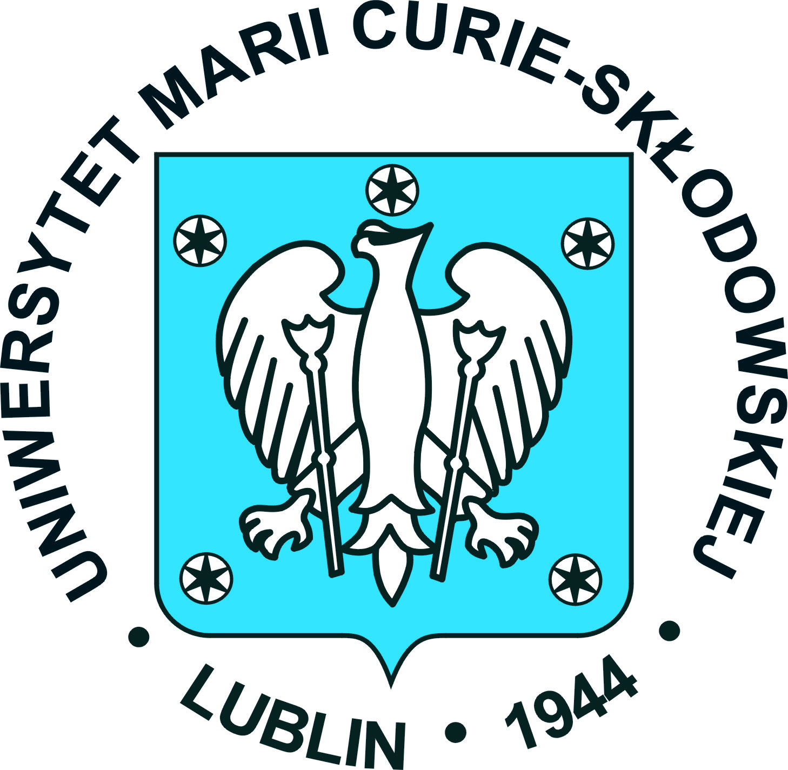

Certified translation of a Polish document into English

RESOLUTION No. XXIV – 26.8/19

of the Senate

of Maria Curie Skłodowska University in Lublin
passed on the 24th day of April 2019

on the byelaws of Doctoral School of Social Sciences

§ 1
On the basis of art. 205 pass. 2 of the act of the 20th day of July 2018. Law on tertiary education and science (Journal of Laws (Dz. U.) of 2018, item 1668 as amended) in connection with art.292 of the act of the 3rd day of July 2018 Regulations introducing the act Law on tertiary education and science (Journal of Laws (Dz. U.) of 2018, item. 1669), the Senate of Maria Curie Skłodowska University passes the byelaws of the Doctoral School of Social Sciences in Maria Curie Skłodowska University in Lublin, constituting an annex to the foregoing resolution.

§ 2
The resolution comes into force on the 1st day of October 2019.

Chairman of the UMCS Senate
RECTOR/University President/

Prof. Stanisław Michałowski, PhD
Fee for the translation duly collected in the amount of 45 PLN, in accordance with the order of the Minister of Justice of the 24th day of January 2005 /Dz. U. of the 26th day of January 2005/.
I, Agnieszka Monies-Mizera, registered sworn translator of English in Lublin, do hereby certify that this is the true version of the Polish document presented to me on the 16th day of May 2019.

Repertory: # 129/P/ 2019

