Signifying Spaces:

Theory, Method, Textual Practice.
Lublin, 26-28 September 2016

Maria Curie-Skłodowska University in Lublin, Poland

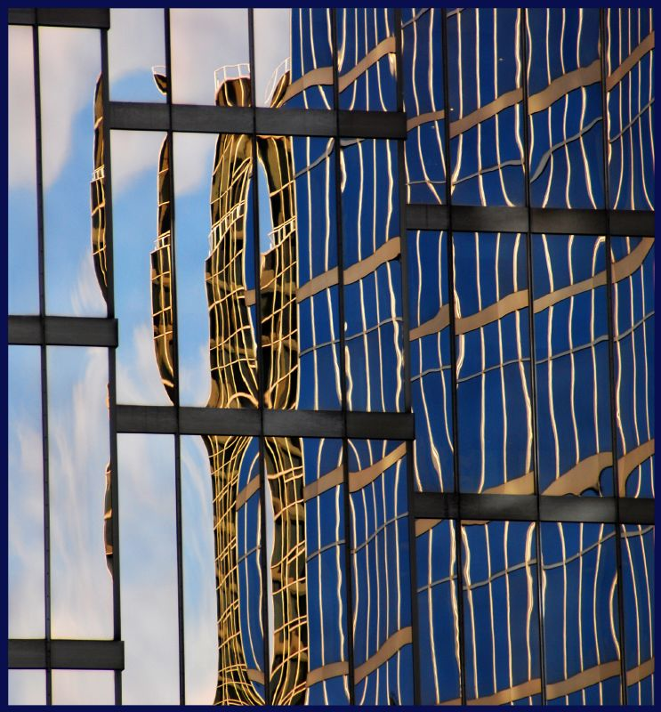

Call for papers
In the influential book Travelling Concepts in the Humanities Mieke Bal advocates a shift in the interdisciplinary work in the humanities from method- and discipline-based to concept-based. Interdisciplinarity, „necessary, exciting, serious, must seek its heuristic and methodological basis in concepts rather than methods,” argues Bal (5). Concepts „offer miniature theories, and in that guise help in the analysis of objects, situations, states, and other theories” (Bal 22). Travelling between different disciplines, concepts pave ways for inter- and trans-disciplinary dialogues and create a methodological ground that may counter the exclusionary methods of separate fields and discourses. Space is one of such defining concepts. It lies at the centre of human experience, cognition and culture; the spatial image of the world is created by man but it also actively forms the person immersed in it.
The conference proposes to explore space as a locus and matrix of meaning. We want to consider spatiality as a theoretical concept, methodological tool and an important aspect of textual analysis. The main focus will be on inter- and transdisciplinary work in the humanities but perspectives considering spatiality as a way of bridging the gaps between the humanities and other fields and disciplines are also welcome. Topics may include, but are not limited to:
– the spatial turn,
– spatial studies in the humanities,
– semiotics of space,
– theories of space,
– space as method,
– spatial aspects in literary and cultural analysis,
– spatial topoi as trans-disciplinary tools (e.g. the city in urban studies, utopia/dystopia in utopian studies),
– representations of space in different media (literature, film, theatre, television, video games).

Please email abstracts of 250 words for papers of 15-20 minutes in length by 30th June 2016 to
signifyingspaces.umcs@gmail.com

Selected papers will be published in the post-conference volume.

Conference website: https://signifyingspaces.wordpress.com/

