|  |
| --- |
| **ATTENTION!**  **Between 20 May and 20 June 2016** only the following students shall file the applications for a place in a dormitory:   * I to IV-year students of long-cycle programmes, * I, II-year bachelor’s degree students (3-year programmes), * I, II, and III-year engineer’s degree students (3,5-year programmes), * I-year students of second-cycle programmes, * doctoral students. |

In order to file an application for a place in one of the dormitories, log into USOSweb, go to the **Application** module in the **STUDENT’S SECTION** tab and click “fill in” on the menu by the housing application.

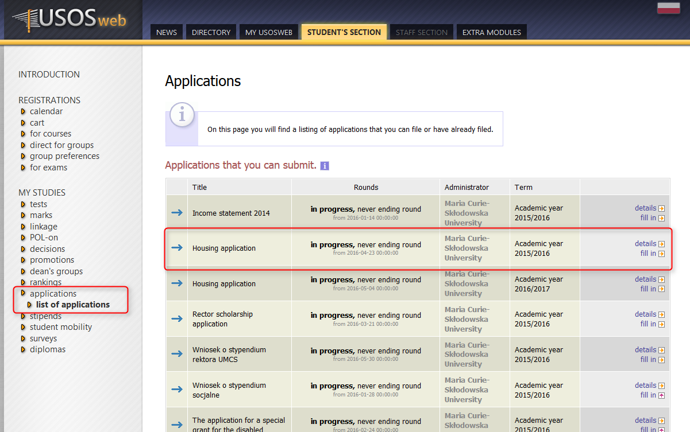

To fill in your application, you need to provide necessary details on subsequent pages.

On page 3 you will be asked to verify the data you entered and state household monthly income **per person for the previous tax year**, for instance, in the academic year 2016/2017 you should state monthly income for the year 2015. Income shall be calculated following the same regulations as apply when calculating the maintenance grant, in compliance with the binding Study Regulations of the University. Students with household monthly income per person above the income threshold that allows them to apply for the maintenance grant may also file housing applications.

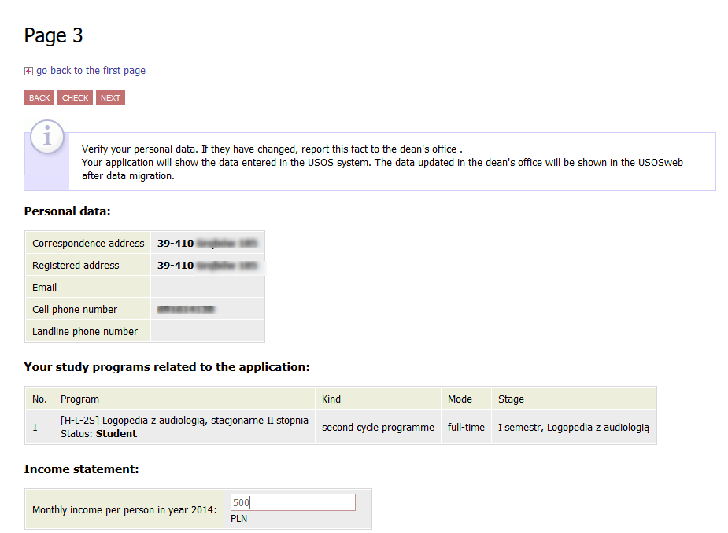

On the next page, state the distance from your permanent place of residence to the University, that is Maria Curie-Sklodowska Square, following the existing traffic routes.

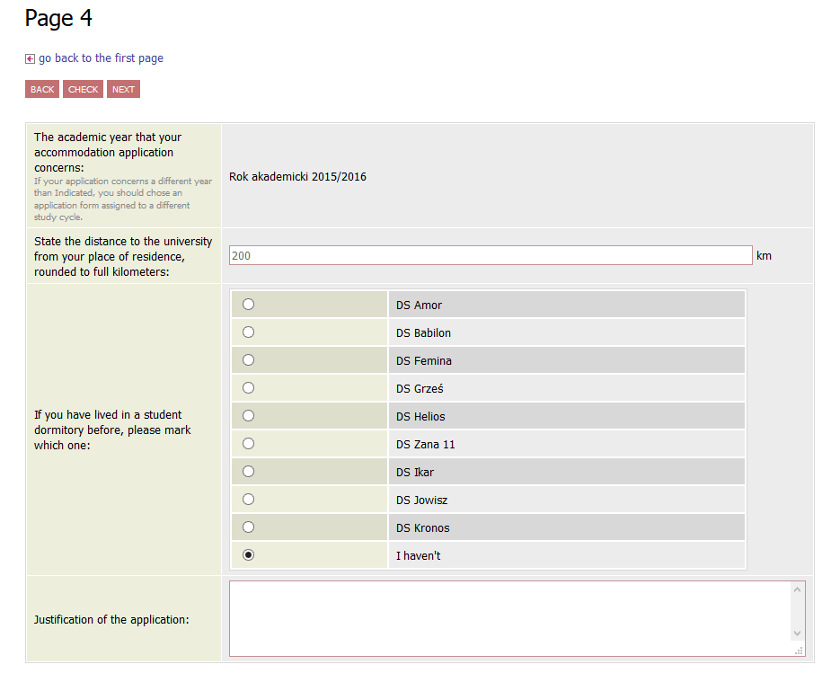

 Check the distance on Google Maps.

On page 5 you may state your next of kin for whom you would like to apply for additional accommodation (your child, your spouse). After your application has been reviewed, you will either be assigned all the places you were applying for or none.

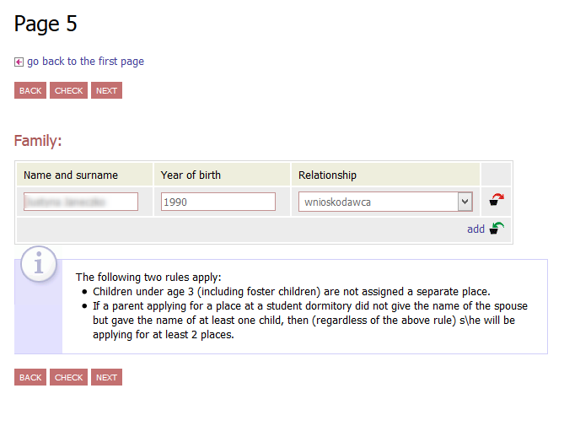

On page 6 you may state any other substantial circumstances that may influence the type of room which will be assigned to you. **You should provide such information in the application and submit it to the Commission for Student Dormitories (the Office of Student Affairs of the Centre for Education and Studies Management, “Helios” dormitory, room 5, Monday–Friday, 9:00–14.30)** **together with other documents** which confirm circumstances referred to in the application e.g. a copy of your parent’s death certificate, a disability-degree certificate, a copy of your child’s birth certificate or a copy of your marriage certificate.

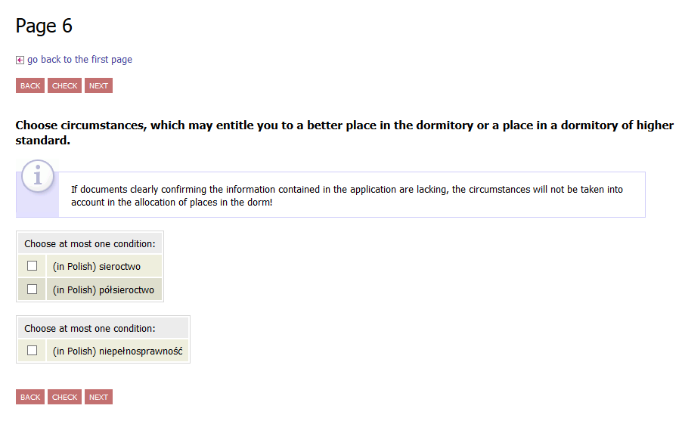

On page 7 you may indicate the persons you request to reside with at a student dormitory.

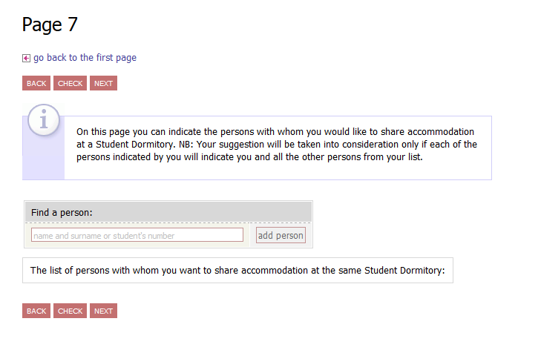

Page 8 includes a description of each dormitory, contact data as well as a list of furniture and equipment available in rooms.

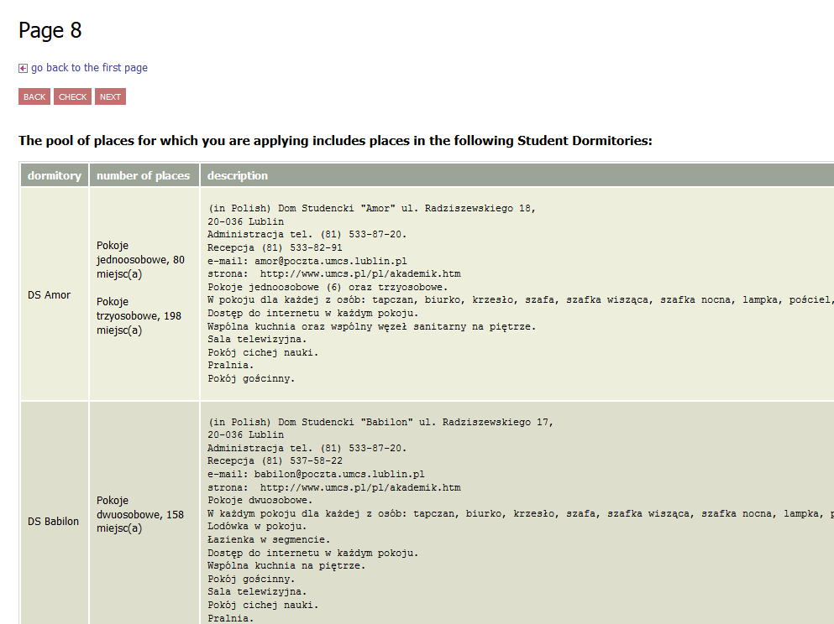

On page 9 you shall indicate the dormitories you would like to be allocated to. You can state your preference by clicking and dragging your choices to the relevant positions in the ranking list. Each student is allowed to apply for a place in any of the available dormitories. **You may also state those dormitories in which you do not wish to be accommodated**. If you drag the name of a dormitory onto the box “Student dormitories where you would not like to be accommodated” at the bottom of the page, you will indicate that you do not want to reside in this particular dormitory even at the expense of not receiving any university accommodation.

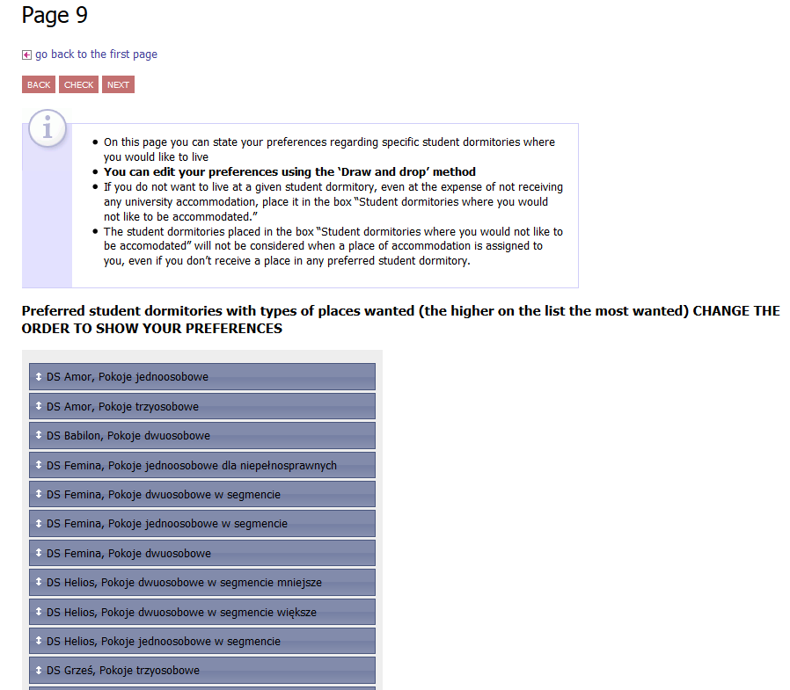

To complete your application, click **REGISTER** on the last page. After doing so, you will no longer be able to edit your application. Applications that were not registered will not be reviewed.

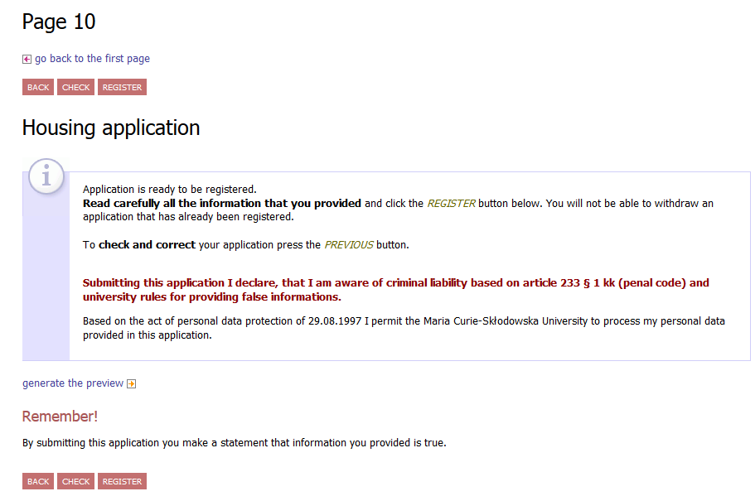

**ATTENTION!** It is not necessary to print out and deliver a paper form of your application to the Commission for Student Dormitories.

You will be notified via e-mail once your application has been reviewed. The results will be included in the details of your application in USOSweb. A place in a dormitory was allocated to you if a name of a dormitory appears in the box “Assigned dormitory”. If there is “None”, you were not awarded any place of residence in a dormitory.

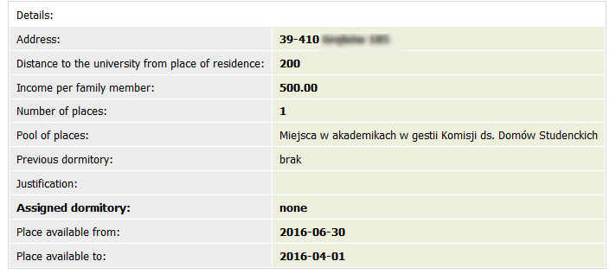

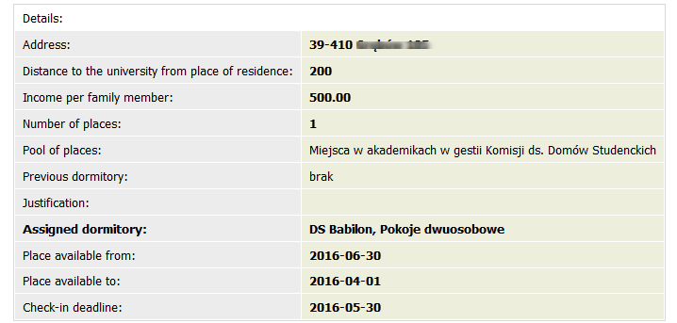

**The choice of assigned places must be confirmed in USOSweb by 20 July** by clicking “Confirm”. The status of your application will change from “Accepted” to “Confirmed”. **Should you not perform this operation before the aforementioned deadline, your application will be denied. It will not be possible to retrieve the place that was previously allocated to you.**

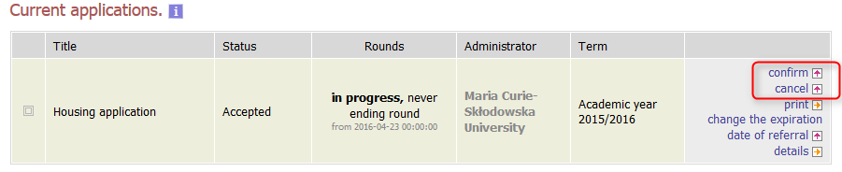

If you wish to give up your assigned place in a dormitory, **you are obliged** to report this fact in USOSweb by clicking the “Cancel” button. Following this operation, the status of your application will change to “Abandoned”. Once you have given up your assigned place in USOSweb system, it cannot be undone.

If you wish to re-apply for a place in a dormitory, you may submit an application in paper form to the Commission for Student Dormitories. However, your application may be reviewed only after 2 October, which is past the period of lodging for a given academic year.

Should you have any further questions, please contact any of the employees at the Office of Student Affairs of the Centre for Education and Studies Managementvia telephone + 48 533-86-27 or e-mail [akademik@poczta.umcs.lublin.pl](mailto:akademik@poczta.umcs.lublin.pl).