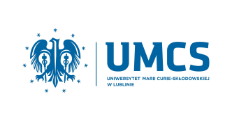 | ERASMUS+ PROGRAMME  Maria Curie-Sklodowska University,  Lublin, Poland  http://www.umcs.pl/en/  Erasmus code: PL LUBLIN01 | 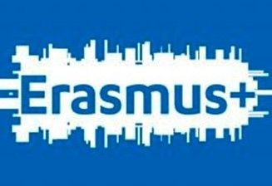

APPLICATION FORM
2nd Erasmus Education Week at Maria Curie-Sklodowska University
Lublin, Poland
Faculty of Education Studies and Psychology

19th – 22nd March 2018

Name of the Delegate
Position
Specialization
Affiliated Institution
Erasmus Code
Erasmus Programme
(STT, STA)
Types of teaching programme (lecture/practice/workshop)
Institutional website
E-mail address
Telephone number

